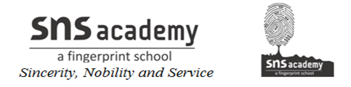
ANNUAL PLAN 2019-2020
Grade XII - Computer Science

Month | Unit / Topic | No. of periods
April | - Database Concepts  - SQL | 12+10
May | Holiday | -
June | - Communication Technologies  - OOP Concepts | 15+6
July | - Function Overloading  - Class & Objects | 18+10
August | - Constructor & Destructor  - Inheritance  - Data File Handling | 15+10
September | - Pointers  - Arrays, Linked list  - Stacks & Queues | 15+12
October | - Boolean Algebra | 15
November | - Revision
December | - Revision
January | - Revision
February | - Revision
March | - Revision

